## Todo: to record all of the following “transcripts”

# Part 1) Analyze a speech

## 1st row

## Lexical resource

* demographic /ˌdɛməˈɡræfɪk/

1. The demographics of a place or society are the statistics relating to the people who live there. 人口统计数据 e.g. ...the changing demographics of the United States. …变化的美国人口统计数据。 V.S**. 人口普查 population census**

2. In business, a demographic is a group of people in a society, especially people in a particular age group. 特定年龄段的人口 e.g. This **ad campaign’s** **target demographic** is young yuppies. E.g. The station has won more listeners in the 25-39 **demographic**. 这个电台吸引了更多25-39岁年龄段的听众。

* **antelope** /ˈæntɪˌləʊp/ An antelope is an animal like a deer, with long legs and horns, that lives in Africa or Asia. Antelopes are graceful and can run fast. There are many different types of antelope. 羚羊
* cave painting 洞穴里的画
* **mythology**: [mi'θɔlɔdʒi] n. 神话；神话学
* **be engrossed[ɪn'ɡrəʊst] in 全神贯注的；专心致志的 = be absorbed in = be immersed in 浸入的；专注的**
* carve V.S. engrave sth on walls/metal/rock V.S. personal inscription;
* **clay tablet: 泥版**
* engrave:   
  (在墙壁，石头上）刻上 If you **engrave** something (e.g. rock, wall, metal, bottle) with a design or words, or if you engrave a design or words on something (e.g. wall, rock), you carve or **inscribe**刻在 the design or words into its surface. e.g. Your wedding ring can **be engraved wit**h a **personal inscription** at no extra cost. 你的结婚戒指可以刻上 个人题字 不另收费。 e.g. The shop will also **engrave your child's name on** the side. 商店也将在一侧刻上你孩子的名字。 ...a bottle **engraved with** her name. …一个刻有她名字的瓶子。 e.g. In the memorial of Korea War, all heroes' names are **engraved on** the side wall. = The side wall of this monument **is engraved with** all heros' names
* inscribe, inscription /ɪnˈskraɪb/

1. If you inscribe words on an object, you write, carve or even engrave the words on the object. 题写; 刻 e.g. Some galleries in LiHua Women's Univeristy, commemorate donors by inscribing (engraving) their names on the walls. 一些展览馆把捐赠者的名字刻在墙上以纪念他们。 //纪念sb. commemorate sb.

2. If you inscribe something in the front of a book or on a photograph, you write it there, often before giving it to someone. 题字题赠(送书／照片给别人）　 [ 题写了xxx字: inscribe the words: "xxx"; 个人题字: a personal inscription ]　 e.g On the back of the book, I had inscribed the words: "Here's to Great Ideas! John." 在背面,我题写了这样的话：“献给伟大的思想！约翰 e.g. Your wedding ring can be engraved with a personal inscription at no extra cost. 戒指可以刻上 个人题字 e.g. You can engrave the ipad with a personal inscription without extra cost. //engrave a wall/rock with a design or word = engrave a design or word on the wall/rock

* **[遗] 突变；变化 mutation [mju:'teiʃən]**

1. (biology) an organism that has characteristics resulting from chromosomal alteration词： [mutant](javascript:void(0);)   /   [variation](javascript:void(0);)   /   [sport](javascript:void(0);)
2. (genetics) any event that **changes** genetic structure; any **alteration** in the inherited nucleic acid sequence of the genotype of an **organism [** [**genetic mutation**](javascript:void(0);)**基因改变  /**[**chromosomal mutation**](javascript:void(0);)**]**
3. **变化**a change or alteration in form or qualities

* take sth for granted

It's something we all **take for granted**: our ability to look at an object, near or far, and bring it instantly into focus.  这是一个我们**习以为常**的事情：不管物体是远是近，我们的眼睛总能在看到物体的时候迅速完成对焦。

## Video:

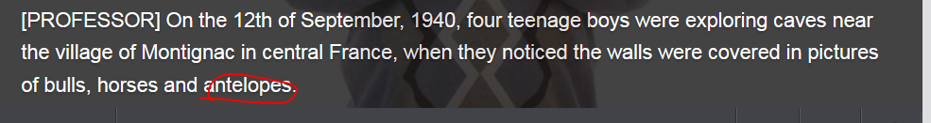









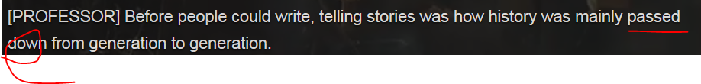



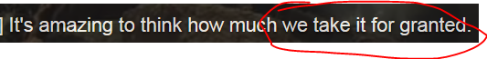





clay tablet 泥版









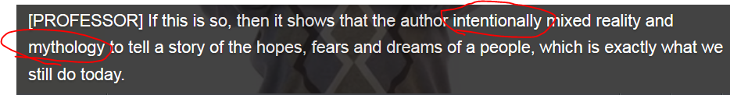

* intend to do; intention; intentionally = on purpose= deliberately
* mythology: [mi'θɔlɔdʒi] n. 神话；神话学
* carve V.S. engrave sth on walls/metal/rock V.S. personal inscription;
* clay tablet: 泥版



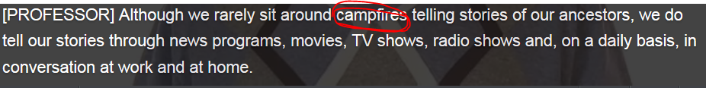

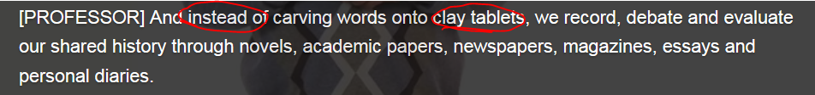









## How to make a speech

1. Analyze a speech, including the target audiences **[target demographic],** the allowed duration time, venue/location, venue HW&SW
2. Early transcript, PPT preparation. Pay attention to the following :

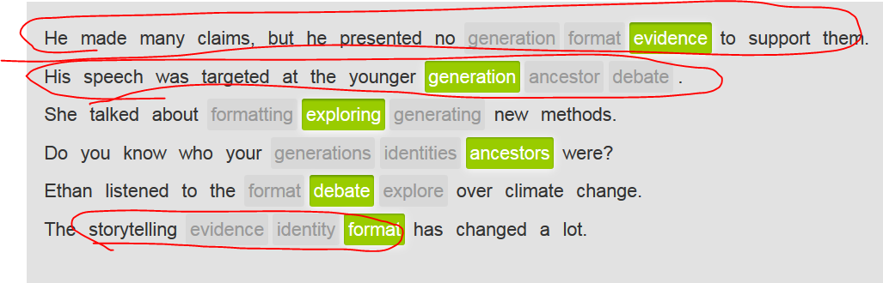

1. Rehearsal. Attention to your gesture, body language, tone, voice, eye contact, and **Signposting during your speech, and** using visual aids during your speech
2. Xxx
3. Xx
4. xxx

## Types of speech

* Wedding toast
* Birthday toast
* 大学发表毕业演讲 Commencement speech   
  e.g. During a commencement speech at Stanford University, Jobs said: "No one wants to die. And yet death is the destination we all share.  乔布斯在美国斯坦福大学发表**毕业演讲**时说：
* retirement speech
* inauguration speech (e.g. U.S. president inauguration speech )

## 2nd row **设路标signposting**

## Lexical resource

* signpost /ˈsaɪnˌpəʊst/

A signpost is a sign where roads meet that tells you which direction to go in to reach a particular place or different places. 路标 e.g. Turn off at the **signpost** for the East 71st Street exit. 在指向东第71街出口的**路标**处转弯。

* ”让行”的交通指示牌 yield sign/give-away sign

In road transport, a yield sign (Canada, Ireland, South Africa, South Korea and the United States) or give way sign (United Kingdom, other Commonwealth and English-speaking countries) traffic sign indicates that each driver must prepare to stop if necessary to let a driver on another approach proceed. A driver who stops has yielded让行 the right of way to another. E.g. A yield sign is a triangle with a white background and a red border.  避让标志牌是白底红边三角形。 E.g. Some of these traffic circles position a stop sign or a yield sign on every incoming road that gives priority totraffic already in the circle有些环形交通枢纽，在每一入口的道路皆设置“停车”或“让行”的交通指示牌，方便已在环形交通枢纽中的车辆；

## **Signposting** during your speech**设路标**

在演讲时，你要把观点组织起来，使其通俗易懂。要做到言辞清晰，你可以在每个部分**signposting** （设路标）或者明确告诉听众下一段要说什么. A signpost is a sign where roads meet that tells you which direction to go in to reach a particular place or different places. 路标。 During a speech, a signpost indicates where you are to audiences, such as to begin a speech, to throw your 1st point, to go to the next point, or to end your speech.

### 这类signpost示意听众你即将开始演讲并陈述第一点

|  |  |
| --- | --- |
| **To start with,** I'd like to thank everyone for coming. | **首先**，我要感谢各位的光临。 |
| **I'd like to begin by talking about** our new books/the new project. | **我想先讲一讲**我们的新书。 |
| **The first point I'd like to make is that** the library is a safe place to meet. | **我想讲的第一点**是图书馆是一个安全的见面场所。 |

### 这类signpost示意听众你已经讲完一点，并准备开始说一个新观点

|  |  |
| --- | --- |
| **In addition,** we'll be open on Sundays. | 此外，我们礼拜天会开放。 |
| **Another issue to consider is** how we will fund the full-time employee. | 还有一点可以考虑的是，我们会怎样为全职员工提供资金支持。 |
| **Another point is that** students will be able to get help from tutors **here.** | 另外一点是学生可以从这里的助教那里获得帮助。 |
| **More than this,** the library will foster personal growth.  **// More than this**暗指下一个观点比上一个重要 | 除此之外，图书馆可以促进个人成长。 |

### 此类signpost来告诉听众你即将结束讲话

|  |  |  |
| --- | --- | --- |
| **Finally,** I want to thank local citizens. | 最后，我想谢谢本地的市民。 | |
| **In summation,** we are very fortunate. | | 总之，我们非常幸运。 |
| **To sum up, we are entering a new era.** | | 总之，我们进入了一个新时代。 |
| **In conclusion, the new library is a tremendous resource.** | | 总之，新图书馆是一个巨大的宝库。 |

**In a nutshell, 极其简括地说**

|  |
| --- |
|  |

## (Stop Video) 2nd row > 3rd tab



## (stop Video) 3rd row) Using visual aids during your speech

## (stop Video) 4th row Analyze the speech

Your friend is preparing to give a short speech to the city about library donations. Help her analyze the speech and make suggestions to improve it.

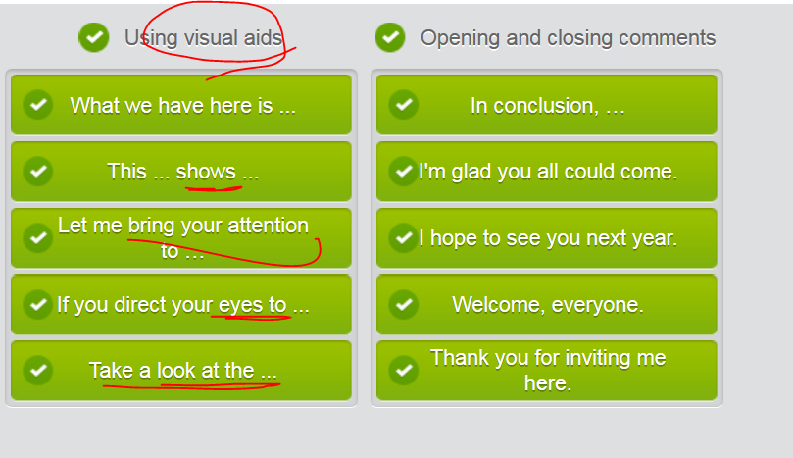

# Stopmp3: Part 2) Make speech more persuasive and compelling,convincing

## Lexical resource

* 捧腹大笑 a belly laugh
* **在众目睽睽之下犯大错/丢脸 /打脸 fall fla[t o]n your face**
* Black Death： a form of bubonic plague pandemic in Europe and Asia during the 14th century, when it killed over 50 million people 黑死病
* sexist /ˈsɛksɪst/

1.ADJ If you describe people or their behaviour as sexist, you mean that they are influenced by the belief that the members of one sex, usually women, are less intelligent or less capable than those of the other sex and need not be treated equally. (尤指对女性) 性别歧视的表不满 e.g. Old-fashioned sexist attitudes are still common. 老套的性别歧视态度仍然很普遍。

2.N-COUNT A sexist is someone with sexist views or behaviour. 性别歧视者 e.g. It's got nothing to do with sexism. You know I'm not a sexist. 这与性别歧视毫无关系。你知道我不是个性别歧视者。

* sexism /ˈsɛksɪzəm/

1.N-UNCOUNT Sexism is the belief that the members of one sex, usually women, are less intelligent or less capable than those of the other sex and need not be treated equally. It is also the behaviour which is the result of this belief. (尤其对女性的) 性别歧视

* feminist /ˈfɛmɪnɪst/   A feminist is a person who believes in and supports feminism. 女权主义者

e.g. Only 16 percent of young women in a 1990 survey considered themselves feminists.认为自己是女权主义者。2.ADJ Feminist groups, ideas, and activities are involved in feminism. 女权主义的

* discriminatory /dɪˈskrɪmɪnətərɪ/  + indiscriminatively

1.ADJ Discriminatory laws or practices are unfair because they treat one group of people worse than other groups. 歧视性的 e.g. These reforms will abolish racially discriminatory laws. 这些改革将废除种族歧视法律。The jokes were discriminatory. I took offense.

* compelling /kəmˈpɛlɪŋ/

1. A **compelling argument/reason/evidence** is one that convinces you that something is true or that something should be done. **强有力的 令人信服的（证据，理由，论点，观点 contention）** e.g. Factual and forensic evidence makes a suicide verdict the most compelling answer to the mystery of his death. 事实和法庭证据使自杀的判定成为对他死亡之谜最令人信服的解答。

2.ADJ If you describe something such as a film or book, or someone's appearance, as compelling, you mean you want to keep looking at it or reading it because you find it so interesting. 引人入胜的 e.g. ...a frighteningly violent yet compelling film. …一部充满恐怖暴力但却引人入胜的电影。

* lenient /ˈliːnɪənt, ˈliːnjənt/ leniently

1.ADJ When someone in authority is lenient, they are not as strict or severe as expected. 宽大的 e.g. He believes the government already is **lenient** with drug traffickers. 对贩毒分子已经很**宽大**了。e.g. Many people believe **reckless drivers** are treated too **leniently**. 很多人认为对**鲁莽的司机**处理得太**宽大**了

* (控诉的责备的)非难的（语气，眼神）; 指责的（语气，眼神）**/əˈkjuːzətərɪ/  accusatory**

An accusatory look, remark, or tone of voice suggests blame or criticism. (控诉的责备的)非难的（语气，眼神）; 指责的（语气，眼神）**[ the accusatory tone; the accusatory look ]** e.g. Honestly express your needs and insecurities in a non-threatening**, non-accusatory way** so your partnerdoesn't get defensive.  不要用威胁或者**指责的语气**。

## Video) Use humor in your speech



 **在众目睽睽之下犯大错/丢脸**





* 







 捧腹大笑

*  your ‘target demographic’







 this leads to my main point











“A, a joke”  

 … Nobody laughs



 















## 1st row >2nd tab Forming adjective

|  |
| --- |
| **形容词构词** |
|  |
| 通过用名词构成形容词可以扩大词汇量。在名词词尾加上其中一个后缀就可以构成形容词：**-ant**, **-ent**, **-ical**, **-ist**, **-ive** 或 **-ous**。 |

|  |  |  |  |
| --- | --- | --- | --- |
| hypothesis | 假设 | hypothet**ical** | 假设的 |
| lenience | 仁慈 | lenient | 仁慈的 |
| race | 种族 | racist | 种族主义的 |
| sex | 性别 | sexist | 性别歧视的 |
| offense | 冒犯 | offensive | 冒犯的 |

|  |  |  |  |  |  |
| --- | --- | --- | --- | --- | --- |
| care | 关心 | care**ful** | 细心的 | care**less** | 粗心的 |
| harm | 危害 | harmful | 有害的 | harmless | 无害的 |
| fear | 恐惧 | fearful | 害怕的 | fearless | 无畏的 |
| power | 权力，能力 | powerful | 强大的 | powerless | 无权的，无力的 |

|  |  |  |  |
| --- | --- | --- | --- |
| discriminate | 歧视 | discrimin**atory** | 歧视性的 |
| accuse | 指控 | **accusatory** | 非难的 /əˈkjuːzətərɪ/  An accusatory look, remark, or tone of voice suggests blame or criticism. (控诉的责备的)非难的（语气，眼神） e.g. ...the accusatory tone of the questions. ...这些问题的非难语气 |
| attract | 吸引 | attractive | 有魅力的 |
| innovate | 创新 | innovative | 创新的 |
| impress | 使钦佩 | impressive | 令人钦佩的 |
| do | 做 | doable | 可行的 |
| delight | 高兴 | delighted | 高兴的 |

## How to express your opinions in **idiomatic expression (地道的表达)**

|  |  |
| --- | --- |
| add your opinion to a conversation | * I think/I’d like to point that/It’s my contention that ( contention: a strong opinion) * That's my honest opinion. * 总的来说(我觉得xx) For what it's worth (FWIW), xxxx e.g. For what it's worth (FWIW) 总的来说(我觉得xxx), modern art is quite valuable.  e.g. FWIW, Mage Armor is quite powerful, but it's a trade off. 总的来说(我觉得xxx)，法师护甲确实很强力，但这是一种交易  E.G. For what it's worth (FWIW), the sculptures will probably be vandalized.   // for what it is worth; an abbreviation used in emails, to say that you are not sure if what you are writing is very useful 不论有没有用〔电子邮件中的缩写，表示不确定正在写的东西是否很有用〕   * That's my two cents (我的一点意见/想法). have few opinion or suggestions.  e.g. Here comes my two cents. Can we change the patent title a little bit?  E.g. I'm sorry for lag. I'm damned busy in crazy APIc killer tasks. Well, I have two cents about your issue. Please check my Red comments. Thank you.  e.g**. If you want my two cents**, public art is an expression of the public itself. |
| **Agreeing with sb.** | * **I'm with you (on this point).** I’m with Vivian on this issue. * I totally agree with you * **You have a point.** * **I was just thinking that myself. 我也正那么想呢** * I cannot agree with you any more * **Tell me about it! Too many compromises**. |
| **disagreeing with** | * Sorry that I’m not with you (on this point). Instead, I’ve got to **side with VV.** * Sorry Jill, but I have to **side with Vivian on that.** * **I’m in my two minds我有两种想法. On one hand xxx, on the other hand.** * Let's just drop it, shall we? * **That's not always the case但事实并非总是如此.** * **Can't see it, myself. 我可不认为** * I’ve gone right off you. = doesn’t agree with sb in a humorous way * **除非我死了（表示强烈反对）Over my dead body.** e.g. You wanna get married with that gangster? My opinion? **Over my dead body**! |
| Use expressions like these to end a heated discussion where people are becoming frustrated or upset. | * 让我们接受彼此的不同观点吧 Let's agree **to** disagree. / Let's agree to disagree on that. * Be careful; **whatever you say** can convey annoyance or a patronizing attitude. |
|  |  |

## Stop: 2nd row**劝说**

发表演讲时可以使用劝说技巧来说服听众考虑或同意你的观点。比如举例支持自己的观点。

|  |  |  |  |
| --- | --- | --- | --- |
|  | In my opinion, the human population boom isn't the end of the world. In fact, it's just a sign of better things to come. First of all, the population will only increase until the end of this century. Then it will decline, bringing an easier life for all of us. Fewer people means more jobs and more available real estate. |  | 在我看来，人口爆炸并不意味着世界末日。实际上它预示着更好的事情即将发生。首先，人口增长只会持续到本世纪末。之后就会下降，所有人的生活都会更轻松。人口减少意味着更多的工作机会和可售房产。 |

你还可以用上数据、史实和图表

|  |  |  |  |  |  |  |
| --- | --- | --- | --- | --- | --- | --- |
| The United Nations expects the population to increase to 10 billion by the end of the century. | | | |  | 联合国预计本世纪末人口将增长到100亿。 | |
| The Black Death killed one third of Europe's population in the 14th century. | | | |  | 14世纪黑死病夺去了欧洲三分之一人口的性命。 | |
|  | After the Black Death, there was the renewed optimism and prosperity of the **Renaissance /rəˈneɪsəns/  ['rɛnəsɑns]** and the **Enlightenment**. |  | 黑死病过后，乐观情绪复燃，文艺复兴和启蒙运动盛极一时。 | | |

通过反问句(**rhetorical  [ri'tɔrikəl, question**) 你可以为听众提供“正确”回答，还可以表达自己的观点。 **( politians/PR’s rhetoric 华丽的辞藻 used to persuade audience to believe them)**

|  |  |  |
| --- | --- | --- |
| What happens when there's less demand for real estate? Prices drop. |  | 房地产需求减少会导致什么后果？房价下跌。 |
| Should you really care what happens a hundred years from now? Yes, because future generations will be dealing with radical changes. |  | 你是不是一定要关心一百年以后的事呢？是的，因为我们的后代将要面临彻底的改变。 |

另一个劝说技巧是告诉听众，你以前跟他们中的许多人一样有不同意见，但现在你的想法改变了，暗示他们也应该改变看法

|  |  |  |
| --- | --- | --- |
| I used to be worried about overpopulation. I've changed my mind, **though**. I now look at our **booming population** as a chance at a new model for society. |  | 我以前也担心人口过剩。但现在我改变看法了。我现在把人口爆炸看成是建立社会新模式的一个机会。 |

## Reading

I **used to** be worried about overpopulation. I read statistics from the UN about how we added another billion people to our planet every decade or so. I couldn’t help but assume that **an exploding population** would naturally lead to ugly things. I’ve changed my mind, **though**. I now look at our ‘**booming population’** as a chance at a new model for society.  
  
The world’s population is expected to increase to about 10 billion people by the end of this century. After that, it will probably begin to decline. 'So what?' you might ask. 'Won't we all have run out of food and land before then?' But wait a minute: let’s assume that our current economic models remain largely unchanged for the next two or three generations. What happens when the world’s population begins to decline? It turns out that the answer to that is: LOTS happens.

* First, fewer people on Earth will radically alter one key economic component of modern life: real estate. One assumption of real estate operating is that there are more people vying for **less and less land**. But **a declining population is likely to throw this model upside down**: what happens when fewer people are demanding their own homes, lands, vacation cottages? That will radically alter the nature of our cities to start. **Later**, even the countryside will feel the effects. This can be seen in many developed countries, in fact, which have become highly urbanized, causing rural land prices to drop dramatically. Take away land speculation and suddenly the price of land drops. And that begins to lift a heavy burden off the world's poor.
* In addition, a declining population means fewer workers which means **scarce labor**. What happens when labor becomes scarce? **Wages go up**. As this happens, the burdens that poor people face diminish. Consider Europe for a moment: after dramatic falls in populations caused by the Black Death in the 14th century, societies changed radically. And while numbers fell dramatically at first, change came about in the subsequent generations. It came about slowly, in other words: wages increased, land reform began, a burgeoning middle class took shape and altered the nature of civilization. And after that, forward-looking social movements like the Renaissance, and later the Enlightenment.   
    
  And why is any of this important? Should we really care what is going to happen a hundred years from now**? It matters** because radical changes in societies often bring about dangers—dangers to the poor, the rich, the aristocracy, the marginalized. The entire natures of our societies are likely to be overhauled and very powerful interests will fight against these changes. Much of what drives human fear is fear of the unknown and make no mistake about this: fear is going to be a large part of what people experience when they see their cities, governments and countries changed radically.   
    
  But if we can anticipate the changes, if we can look back at the past as a way to predict what might happen in the future, we can mitigate some of that fear with knowledge. The future is changing and will change our lives, make no mistake about that. It’s up to us to handle and adapt to that change so as to improve the lives of us all. Thank you.

## Reading

**First** , fewer people on Earth will alter one key economic element of modern life: real estate. One assumption of real estate is that there are more people competing for less land. But what happens when fewer people are demanding their own land and homes? That will radically alter the nature of our cities to start. **Later** , the countryside will feel the same effects as the city**. In addition** , a declining population means fewer workers, which means scarce labor. Scarce labor**. In addition** means higher wages. As this happens, the burdens poor people face diminish. Consider Europe: after a dramatic fall in population caused by the Black Death in the 14th century, societies changed radically: wages increased, land reform began and a burgeoning middle class took shape. And after the rise of the middle class, forward-looking social movements like the Renaissance, and later the Enlightenment, took place.

## 3rd row Sequence markers

A few years ago, the air I breathe started killing me. I had been suffering from some dizziness and was often out of breath and when I went to the doctor’s, she asked how long I’d been smoking. When I told her that I didn’t smoke, she asked if I lived in a polluted city (I was visiting the doctor while back home). And, yes, the city where I have lived for the past few years is terribly polluted, especially the air. The doctor suggested I move. My lung capacity had fallen by nearly half. Naturally, I don’t live in this polluted city lightly and my family, career, and friends are all there. So moving is not really an option. She insisted I stop running every morning in a park near my home.

|  |  |
| --- | --- |
| Upon returning to the city in which I live, my family and I began discussing some ways that we could counter-balance the pollution our bodies are dealing with every day. And in exploring alternatives, we learned that there are three basic kinds of plants that can have a huge effect on the air we breathe. Plants can actually clean the air. |  |
|  |

The three plants are called Mother-in-Law’s Tongue, Areca palm, and Money Plant.  First, Mother-in-Law's Tongue is a common plant which at night converts CO2 into oxygen. We put up several large plants in our bedroom and living room where we spend a lot of our time in the evening. The second plant is Areca palm. We put up four shoulder-high plants in our dining room, two in our living room and one in each of our bedrooms; we need to wipe the leaves every day to maximize the oxygen-producing effects. We had to grow them in vermi manure, which is sterile, or hydroponics, and take them outdoors every three to four months. The third plant is the money plant, and this is again a very common plant. This particular plant removes formaldehydes and other volatile chemicals from the air.

|  |  |
| --- | --- |
| These three plants can help produce clean, fresh air that increases blood oxygen. But that’s not all. There are anecdotal reports that the plants help increase productivity. An artist who lives in the top floor of our apartment building says she feels more creative with all the plants and clean air now a part of our building. |  |
|  |

And why does any of this matter? It matters because as our population increases, we require more and more counter-effects to our polluted cities. And more people are moving into cities, which makes the problem even worse. By considering how plants can help clean the air, city planners can make urban citizens’ lives healthier while, at the same time, making cities more beautiful and livable urban environments. At my last checkup, my doctor said my lungs look much improved and I have taken up running again. I bought a treadmill—only indoor running for me!

## 4th row Video

# Part 3) Giving a “retirement speech”

## 1st row

## Video: a retirement speech







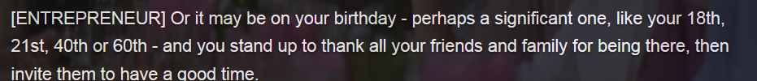

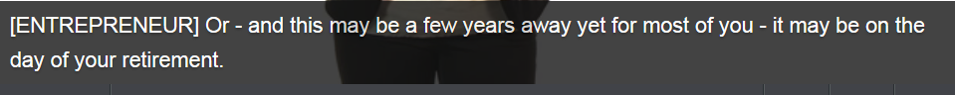

























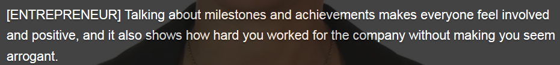















## Lexical resource

* **nerve-racking 神经紧张的/神经紧绷的/伤脑筋的 [ a nerve-racking experience; a nerve-racking day; a nerve-racking situtaion ]**e.g. A nerve-racking situation or experience makes you feel very tense and worried. (令人)神经紧张的 e.g. The women and children spent **a nerve-racking day** outside waiting while fighting continued around them. 妇女和儿童们在等待中度过神经紧绷的一天。



* conventions 习俗
* one-liner 俏皮话 小笑话，俏皮话A one-liner is a funny remark or a joke told in one sentence, for example, in a play or comedy show. (戏剧、喜剧表演等中的单句)俏皮话 e.g. The book is **witty** and peppered with good **one-liners**. 这本书 **诙谐幽默**，**俏皮话**随处可
* **回忆往昔,漫步记忆的小径 took a trip down *memory lane* / walk down memory lane e.g. Let’s start to walk down memory lane**
* **First**, Zuckerberg **took a trip down *memory lane*/walk down memory lane.** He said his best moment at Harvard was when he met his future wife, Dr. Priscilla Chan. ("I turned to her and said, I'm getting kicked out in three days so we need to go on a date quickly.") Chan
* milestones 里程碑
* toast 敬酒, wedding toast 敬酒speech，敬酒词;   
  **Let’s toast to** heath, happiness, and bright future of this amazing couple.

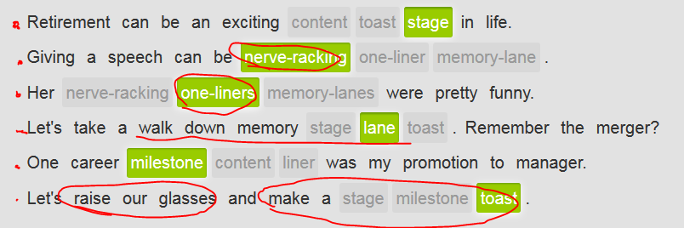

## 2nd row: Signposting during your speech设路标

Signposting during your speech设路标, 在演讲时，你要把观点组织起来，使其通俗易懂。要做到言辞清晰，你可以在每个部分signposting （设路标）或者明确告诉听众下一段要说什么。

A signpost is a sign where roads meet that tells you which direction to go in to reach a particular place or different places. 路标。 During a speech, a signpost indicates where you are to audiences, such as to **begin a speech (Opening and closing remarks),** to throw your 1st point, to go to the next point, or to end your **speech (Opening and closing remarks).**

e.g. the following signposts - **Opening and closing remarks**

* **I’d like to begin with** a quote by Benjamin Franklin.
* **To start,** let’s all stand and give John a round of applause .
* **To sum up,** it won’t be the same in our department without you.
* **In conclusion ,** our business will suffer without your awesome sales skills.
* One reason we'll be sorry to see him go is that he has saved the company so much money.
* **Two important points** are that he has a great sense of humor and always cheers everyone up.

## (Stop video) 1st tab, Need to write down this video script

## (Stop video) 3r row – a retirement speech

( pay attention to the **signposts** during a speech, e.g. opening and closing remarks and how to begin your 1st point and go to the next point)

( signpost: opening remarks) Good evening and welcome everyone to my **retirement party**. It’s finally here and it’s really difficult to believe! I have to say that **I have mixed emotions about retiring**. It is great to be able to look forward to a future with more **time on my hands** and the ability to do so many of the things that I’d always said I wanted to do. However, I do feel some sadness at leaving something that has been such **an important part of my life.**  
Everyone at this bank has been like family to me. **Even though** I will still see many of you after I leave, today I feel like I am moving away from home. There are great things in the future and yet, knowing that I won’t see you all every day is pretty hard to imagine.  
  
I won’t see Max each morning sitting at the front door as I walk into the building. I won’t see Sharon at the desk outside my office. I won’t see the rest of you in the hallways and the lunchroom and we won’t be talking about things like the **absurd/ridiculous** number of parking tickets the city is handing out, or the great burgers they have at Nation’s Café, or the summer heat wave we can’t wait to have end. I will truly miss all of you and all of our conversations, not only the ones I just mentioned.  
  
**(a signpost) Another issue that needs to be addressed** is how wonderful this institution is. I have enjoyed my job at United Bank and I know we have done some great things together. We have an awesome team to work with and Mr. Robertson, our president, has always done everything in his power to make sure we could get our job done well. Thank you, sir, for all of your support over the years. I know the bank will continue with its growth and innovation because of your leadership and our team’s efforts. I hope that all of you feel as fortunate to work here as I have.  
  
But it is time to move on.  
  
Oh yes, **(a signpost)** there is one more thing I wanted to mention. On a personal note I’d like to thank my wife, Deedee, for her support throughout the years. I love you, honey, and I am looking forward to spending more time with you and the kids. Deedee also knows that without you all, I would have been home late every night and she and the kids would never have seen me. Thanks to all of you for **helping me out** by making me go home when I was sure there was just one more thing that had to be done.   
  
(**a signpost: closing remark) In conclusion,** I’d like to thank you all for being here today and having this awesome party for me. I am truly blessed to have you all in my life.

## (Stop video) 4th row-Give a retirement speech

our colleague is about to retire from the company she has worked in for over 25 years. She is having trouble with her retirement speech. Help her put it together.

# Part 4 ) A “wedding toast” 祝酒词/祝酒speech

## Guideline: How to write a wedding toast

1. Signpost (opening remarks): Greet the group; introduce yourself; Explain who you will be toasting.; Thank the people giving the party.
2. Signpost (lead to your main point) : Share a story about the person (or people) you are toasting.
3. Signpost (): Indicate positive qualities about the person (or people) you are toasting.
4. Signpost (closing remarks) End the toast by offering a wish and a traditional toast.

## Lexical resources

* **Let’s toast to sth** 祝酒词: e.g. Everyone, raise your glasses. Let’s **toast to the** health, happiness, and bright future of this amazing couple, Jill and SS~
* **Offer a toast to sb. [ offer a toast to the couple ]** e.g. Welcome everybody. As you know, we’re gathering here today to celebrate the fantastic wedding of Houzi and XiaoCao. Being Houzi’s bridesmaid and her bosom friend, it’s my honor to offer a toast to this amazing young couple
* **transcendental** /ˌtrænsɛnˈdɛntəl/

Transcendental refers to things that lie beyond the practical experience of ordinary people, and cannot be discovered or understood by ordinary reasoning.  ...the transcendental nature of God....上帝的超验本质 e.g. A proper transcendental philosophy should show how the two are united into one, part of the same allembracing truth, aspects of the Absolute.  超越哲学可以显示出这两个概念怎样联合成一体，与某些包罗万象的真理是部分相同的，比如绝对 e.g. There is in Frost no God, no transcendental source of guidance or consolation, nothing out there in the world but the material conditions of our circumstances.  没有上帝，没有卓越的指引和安慰

* **ardent love 深深的爱**

e.g. If we look at Daisy and Will, we see a sparkling example of **devotion**奉献 and **ardent love深深的爱**. They always support each other in their career path, life pursuits, and key decisions. The most touching and impressive thing is how deeply affectionate感情 they are with each other. Daisy and Will, I hope that the genuine affection and profound warmth that you feel for each other will last forever.

* **灼热的；激烈的；讽刺的；过早硫化的 [ it’s such a scorcher ]**

Scorching or scorching hot weather or temperatures are very hot indeed. 酷热的 e.g. That race was run in **scorching weather.** 那次赛跑是在酷热的天气里进行的 e.g. Kelly thinks the **scorching temperatures** are behind around three-quarters of thereported deaths.  灼热的气温是约四分之三已报告死者的死亡原因

* **macaroni [,mækə'rəʊn ] n. 通心粉**
* Sb.拘谨的; 拘束的/羞怯的If you say that **[ someone is inhibited ],** you mean that they find it difficult to behave naturally and show their feelings, and that you think this is a bad thing. E.g. She didn't seem inhibited while dancing on the table. 她在桌子上跳舞时似乎并不”拘谨/羞怯的” E.g. Men are more **inhibited** about touching each other than women are. 触摸同性时男人比女人要更加拘谨
* **intoxicated** /ɪnˈtɒksɪˌkeɪtɪd/

1. 极度兴奋的 feel intoxicated = very excited or thrilled. e.g. In his wedding party, he became very intoxicated/thrilled and was high-fiving the bride's father.

2. Someone who is intoxicated is drunk. 喝醉的 e.g. He appeared intoxicated, police said. 他看上去好像是喝醉了。

2. If you are intoxicated by or with something such as a feeling or an event, you are so excited by it that you find it hard to think clearly and sensibly. 陶醉的 E.g. My cousins seem to have become intoxicated by their success. 我的堂兄弟们好象已经被他们的成功陶醉了

* **基于这一点, 如上所述: On that note: with all stated**

E.g. So **on that note,** yes, being a **mortal凡人** human is fantastic, but it doesn't give us the right to lord it over other people or creatures.  **如上所述**，做个**凡人**也是很值得骄傲的，但是这并不意味着，我们可以凌驾于其他人活生物之上

* **commemorate sth 纪念** sth e.g. One room contained a gallery of paintings commemorating great moments in baseball history. 陈列着纪念棒球史上伟大时刻的绘画作品  
  e.g. I wrote a romantic poem to **commemorate your wedding**, and my experience as a **bridesmaid/the maid of honor**
* conceived; conceivable, conceivably; **inconceivable无法/难以想像的, inconceivably**
  + 1. If you cannot conceive of something, you cannot imagine it or believe it. 想像; 相信 **[ 你无法想像xxx cannot conceive of sth; cannot conceive that xxx = it's inconceivable that xxx ]** e.g.I just can't even **conceive of** that quantity of money 无法想像那样一笔数量的钱 eg **It's inconceivable that** he committed suicide even. eg **It sounds inconceivable but** is the naked truth. 这听起来不可思议/无法想像的 e.g. **We could not conceive that/It’s inconceivable that** he might be dead soon. 无法相信他可能很快就会死去**。 [可以想像(发生了xxx); It's conceivable that xxx]** e.g. **It's conceivable that** the new project would be a **daunting** task, full of **formidable challenges**艰难的挑战. ]
  + 2. If you **[ conceive a plan or idea ] ,** you think of it and work out how it can be done. 构想 [ conceive a good idea/plan/frame ]
  + 3. When a woman **[conceives a child]** or conceives, she becomes pregnant **[ conceive a BB ]** e.g. Women and men who have traveled to the virus affected area should wait eight weeks to **conceive** after their return, while men with symptoms should wait a full six months because of the long **incubation [医] 潜伏**
* **top of the bill 最主要的节目; 吸引人们眼球的 e.g. In this day and age, large creatures are more likely to be top of the bill.  更吸引人们眼球的却可能是大型动物**
* mortal /ˈmɔːtəl/

1. If you refer to the fact that people are mortal, you mean that they have to die and cannot live forever. (凡人)终有一死的 e.g A man's lifecycle is deliberately designed to be mortal. He grows, he ages, and he dies.

2. 终有一死 mortality e.g. She has suddenly come face to face with her own mortality. 她已经与死神面对面了。[ mortality rate ]

3. You can describe someone as **a mortal** when you want to say that they are an ordinary person. **凡人, 普通大众, 俗人 [ the ordinary mortal ]** e.g. In Chian, train tickets seem unobtainable to **the ordinary mortal** during the spring "migration".

4. You can use mortal to show that something is very serious or may cause death. 致命的 mortal, deadly = lethal, fatal e.g The police were defending themselves and others against **mortal danger**. 致命的危险.致命地 mortally. e.g. He falls, **mortally** wounded. 他摔了，伤得很重。

6. You can use mortal to emphasize that a feeling is extremely great or severe. 极度的(强调) When self-esteem is high, we lose our mortal/extreme fear of jealousy. 当自尊心很强时，我们会失去对嫉妒的极度恐惧。=> ADV 极度地 mortally Candace admits to having been "mortally/extremely embarrassed." 坎达丝承认曾经“极其尴尬”

=> N) [ mortality rate = death rate 死亡率; a high [low] mortality 死亡率高[低]; the mortality from automobile accidents 车祸死亡人数; the mortality table 死亡率表 eg The Ebola virus outbreak has gotten deadlier. The **mortality rate** has increased from 50% to 70%. **// death toll 死亡人数**

=> mortal V.S. immortal /ɪˈmɔːtəl/ (不死的, 长生不死 ; 神仙；(永垂不朽)不朽的, 万古流芳的)

1. Someone or something that is **immortal** is famous and likely to be remembered for a long time. (永垂不朽)不朽的, 万古流芳的**。 [ immortal love story 不朽的的爱情小说 ]** e.g. The families and their lawyer are coming forward as their **brush with history与历史擦肩而过的经验** is **immortalized 使名垂千古** in a new **Hollywood blockbuster 好莱屋大片**. The film "Snowden" depicts the tense days when the NSA **whistleblower/debunker告发者** went underground in Hong Kong, in a bid to evade/dodge/avoid US and Hong Kong authorities, as well as the world media. Snowden made his first **bombshell**爆炸性消息 revelations about controversial US surveillance programs in an interview with the Guardian newspaper in a room in Hong Kong's Mira Hotel. //告发者；检举者 (揭穿真面目者 ) : whistleblower = debunker; 爆炸性消息/惊天动地的大消息/爆炸性新闻: a bombshell

2. An immortal is someone who will be remembered for a long time. 不朽的人物 ...the players considered to be the immortals of the game. …被认为是该运动项目不朽人物的运动员们。

3. 不朽 immortality [ɪmɔː'tælɪtɪ] e.g. Some people want to achieve **immortality** through their works. 有些人想通过他们的作品 **不朽万古流芳**。

4. Someone or something that is immortal will live or last forever and never die or be destroyed. 不死的, 长生不死 e.g. The **pharaohs /ˈfɛərəʊ/**, after all, were considered gods and therefore **immortal**. 法老毕竟被当作神，因而长生不死。

5. An immortal is an immortal fairy. 神仙 e.g. ...porcelain figurines of the Chinese immortals. …中国神仙的小瓷像。

6. 永生 immortality e.g. The Greeks accepted belief in the immortality of the soul. 希腊人接受灵魂不灭的信念。

7. If you refer to **[ someone's immortal words; immortal lines ],** you mean that what they said is well-known, and you are usually about to quote it. 著名的, 永垂不朽的, 万古流芳的(名句) e.g Everyone knows Teddy Roosevelt's **immortal words/lines,** "Speak softly and carry a big stick." 大家都知道特迪·罗斯福的**永垂不朽的名言**’xxx’. E.G If you're a fan of basketball, you must know Kobe Brian's **immortal words** "Nobody knows what the LA looks like at 4:00 am at dawn, but I know "

* perish:
* If people or animals **perish**, they die or **decease** as a result of very harsh conditions or an accident. (因恶劣条件或事故) 死亡 e.g. Most of the butterflies **perish** in the first frosts霜of autumn.在秋季初霜来临时死亡 V.S. **the deceased 已故的( 死者)**
* (食物)易腐烂的; 易变质的 **perishable ['periʃəbl]=spoilded** 1. food that will **decay** or become **rotten** rapidly if not refrigerated, **perishable = spoiled**. **The perishable foods** will go bad or go spoiled after a short length of time. (食物)易腐烂的; 易变质的 e.g The perishable food like fruit, vegetables, and meat. ... **[ perishable food 易变质的**食物**; perishable product 易腐烂/易变质的物品 ]** e.g. Here come a **disclaimer免责声明**: The company does not accept or **take liability/responsibility** for fragile易碎, valuable贵重 or **perishable goods**. 公司对于xxx不负(法律)责任 **//对xxx负(法律)责任 take liability for sth**
* **[ The heart of the matter lies in xxx; 问题的核心在；The heart of the matter comes down to xxx 问题的核心归结起来就是xxx]**   
  e.g. Despite **the brevity of the speech**, we finally get to **the heart of the matter**尽管演讲很短暂, 我们还是get了核心问题. e.g. **The heart of the matter comes down to** whether or not you believe that love over the internet. 问题的核心归结起来就是，e.g. **The heart of the matter lies in** the reemployment of laid-off workers, which has become a major economic and social problem that affects the overall situation. **焦点集中在**下岗失业人员再就业上
* **brevity短暂 /ˈbrɛvɪtɪ/** **[ The brevity of something 短暂的（演讲，xxxx） ]** is the fact that it is short or lasts for only a short time. 短暂 e.g. Despite **the brevity of the speech**, we finally get to **the heart of the matter**尽管演讲很短暂, 我们还是get了核心问题. e.g. the hardship and brevity of human existence. ...人类存在的艰难及短暂 e.g. **[ The brevity of Qing dynasty ]** marks a black and humiliated history in CHINA.
* **turning points分水岭，转折点e.g. Watershed** is a critical point that marks a division or a change of course; **a turning point: 分水岭，转折点：标志着分界或**过程改变的重要关头 e.g. After the 1sst blind date, the 3rd time date was the **watershed/turning point** in their relationship.
* keynote要旨
  + [keynote speech](javascript:void(0);) 会上发表的主要讲话；政党代表大会上关于施政方针的演说; e.g. He, the Communist Leader, will deliver a **keynote speech** in conference later.
  + [keynote address](javascript:void(0);) 政治性集会中的政策演讲;
  + [keynote speaker](javascript:void(0);)主讲人；大会发言人；主讲嘉宾 ]
* **对xxx负(法律)责任 take liability for sth** e.g. Here come a **disclaimer免责声明**: The company does not accept or **take liability/responsibility** for fragile易碎, valuable贵重 or **perishable goods易腐烂/易变质的物品**. 公司对于xxx不负(法律)责任
* **[荣誉博士头衔honorary doctorate ]** e.g. On Thursday, he returned to Cambridge to collect an honorary doctorate(荣誉博士头衔) and give a **commencement speech** to the class of 2017. Earlier in the day, the 33-year-old posted an image of his honorary荣誉的 doctorate 博士头衔
* **authoritarian /ɔːˌθɒrɪˈtɛərɪən/= autocratic**  If you describe a person or an organization as **authoritarian**, you are critical of them controlling everything rather than letting people decide things for themselves, sb is **autocratic**, being a dictator 独裁的 e.g. Senior officers could be considering a **military coup** to restore authoritarian rule. 高级军官们可能会考虑发动一场政变来恢复独裁统治
* **autocratic /ˌɔːtəˈkrætɪk/ = authoritarian;** an **autocratic** person or organization has complete power and makes decisions without asking anyone else's advice. 独裁的 e.g. The people have grown intolerant in recent weeks of the king's **autocratic/authoritarian ways**. 越难以忍受国王的专制行径
* isolationism /ˌaɪsəˈleɪʃəˌnɪzəm/, isolationist孤立主义者 If you refer to isolationism, you are referring to a country's policy of avoiding close relationships with other countries and of not taking sides in disputes between other countries. 孤立主义; 指避免与别国关系过密或在别国之间的冲突中保持中立 ...the perils of isolationism. ...孤立主义的危险。  e.g. The government had to overcome isolationist opposition to the plan. 政府不得不克服孤立主义者对该计划的反对

## Video



























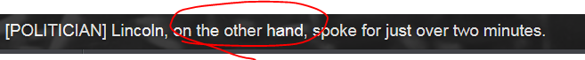

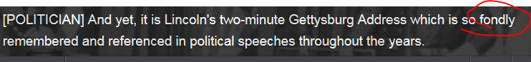

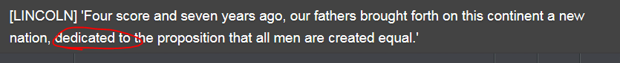





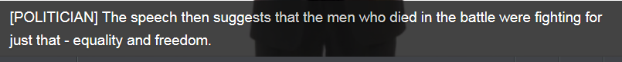







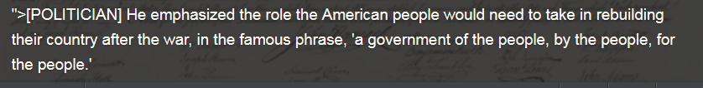

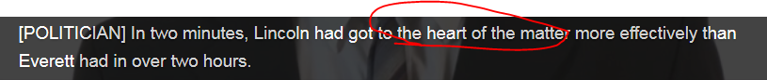



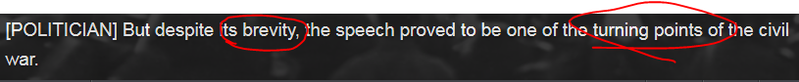

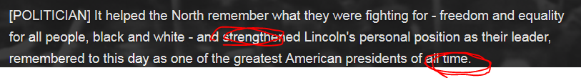

## The negative prefix 'in-'

One function of the prefix 'in-' is to change an adjective with a positive meaning to a negative one.

|  |  |
| --- | --- |
| It's just a bachelor party. You can give a very **informal/casual** speech. | 就是一个**单身派对**。你的演讲可以很随意。 |
| The speech was pretty ineffective [,**ɪnɪ**'fɛktɪv]. Everyone was bored. … the speech **is boring to death**. | 演讲很没有效果。每个人都觉得无聊。 |
| You're so **indecisive** – just say 'yes!' | 你真是**太犹豫了**——说“是”就行了！ |
| I'm too **insecure** to talk in front of big crowds. | 在很多人面前说话让我感到很局促。 |
| Getting down on your knee is not **indirect**. | 下跪可不间接。 |
| He said many nice things, but they sounded **insincere**. | 他说了很多好话，但听上去都不真诚。 |

**注意**，**in-** 并不总是表示**not**. 比如在这类词中，它还可以表示 **into**, **toward**, **upon** 或 **within**。

|  |  |
| --- | --- |
| The cost for the band is not **incidental**. | 乐队开支不是杂项。 |
| Mike and Abby, your love is inspirational. | Mike和Abby，你们的爱情非常励志。 |
| She didn't seem inhibited”拘谨/羞怯的” while dancing on the table. 她在桌子上跳舞时似乎并不”拘谨/羞怯的” | 她在桌子上跳舞时似乎并不”拘谨/羞怯的”。 |
| He became very intoxicated/thrilled and was high-fiving the bride's father. | 他变得非常兴奋，和新娘的父亲击掌。 |

## Stop 3rd (Video) row signpost in the speech – opening and closing remarks

|  |
| --- |
|  |

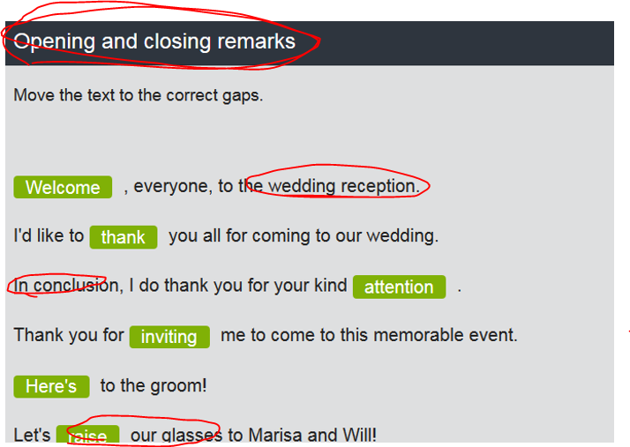

## Wedding speech

Pay attention to the **signposts** used during a wedding speech.

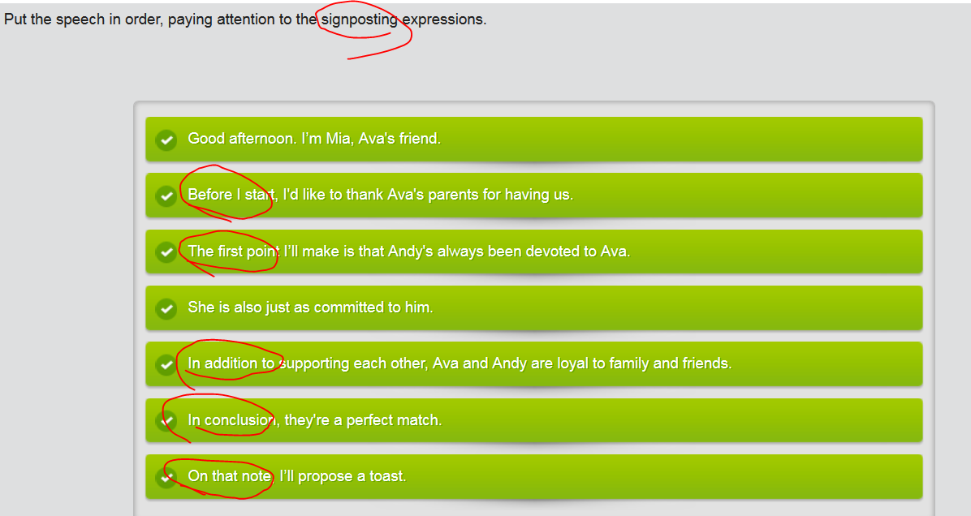

## 4th row: **倒装, 表示强调**

加重句子的强调语气有很多方法。其中一种是将句子的正常语序颠倒。

|  |
| --- |
| 否定副词(**never** / **seldom** / **rarely/hardly**) 移到了句首 **+** 助动词或情态动词 (**had** / **do** / **will**) **+** 句子的主谓语 (**谓语时态保持不变)**+ 其余部分 |

|  |  |
| --- | --- |
| I **have never seen** someone turn so red. | 我从来没见谁的脸会这么红。 |
| Never have I **seen** someone turn so red. | 从来我就没见过谁的脸会这么红。 |
| **You seldom see** such warmth. | 你很少见到这样的热情。 | |
| **Seldom do you see such warmth.** | 很少情况下你会见到这样的热情。 | |
| **I rarely forget a face.** | 我很少忘记一个人的脸。 | |
| **Rarely do I forget a face.** | 很少情况我会忘记一个人的脸。 | |

另外一种颠倒次序、增加强调的方法是采用**cleft**分裂的；劈开的 **sentence**。最简单的一种**cleft sentence**以**It's**开头，强调的是其后的名词。注意第二句里的名词如何比第一句强调作用更明显。

|  |  |
| --- | --- |
| He was attracted to her sensitive nature. | 他被她敏感的特质所吸引。 |
| **It was** her sensitive nature **that** attracted him. | 正是她敏感的特质吸引了他。 |

We three have always been lucky to have these two as our parents. And **never have we been luckier** than today to be able to celebrate this occasion. They lived in a small one-bedroom apartment without any family nearby. Mom wasn’t used to that, but **seldom did** we hear her complain.

In the early years, it was macaroni  [,mækə'rəʊnɪ] 通心粉 and cheese they relied on, not steak and wine. Despite that, **rarely did** we have a bad meal. As our Uncle Ron said at their wedding 50 years ago: it was fate that brought them together. Now, fate has kept them together.

## Writing: Guideline for a wedding toast (is a type of public speech)

Imagine a friend or family member is getting married, and you have been asked to **write the toast**. Use the guidelines in the reference document to help you.

|  |
| --- |
| Guideline: How to write a toast by using proper **signpost (e.g. opening and closing remarks)**   1. Signpost (opening remarks): Greet the group; introduce yourself (bridesmaid); Explain who you will be toasting (offer a toast to sb); Thank the people giving the party. 2. Signpost (lead to your main point) : Share a story about the person (or people) you are toasting. 3. Signpost (): Indicate positive qualities about the person (or people) you are toasting. 4. Signpost (closing remarks) End the toast by offering a wish and a traditional toast. |

### Example

Welcome everybody. As you know, we’re gathering here today to celebrate the fantastic wedding of Houzi and XiaoCao. Being Houzi’s bridesmaid and her bosom friend, it’s my honor to **offer a toast to** this amazing young couple.

**To start with, I’d like to tell you about the first time I met XiaoCao** (//note herein, we use the passive voice when telling a story happening in the past), the most handsome man here today. Houzi hadn’t told me that they were dating. The manager of our downtown office had been telling me for months about his **stellar** employee, XiaoCao, and I finally stopped by the office to meet him. Well, when I stepped into XiaoCao’s cubicle, he surprisingly introduced himself **as if** I **knew (use passive voice for subjunctive mood)** about the relationship between him and houzi. Never have I seen somebody **flush面红 his fac**e so red!

If we look at XiaoCao and houzi, we see a shining example of devotion. They always support one another in their pursuits and decision. The most beautiful thing is how deeply **affectionate**感情 they are with one another. They remind me of how my BF and I were when we first met. Seldom do you see such genuine and precious warmth and **affection**感情.

Cao and houzi, I hope that the warmth you feel for each other endure the years as it has for my husband and me.

Finally, everyone, **let’s toast to t**he health, happiness, and bright future of this fabulous couple. To xiaocao and houzi. “**raise your glasses. Cheers”**

### My writing

**(signpost: opening remarks)**  Welcome everybody. As you know, we’re gathering here today to celebrate the **fantastic** wedding of Daisy and Will. Being Daisy’s bridesmaid and her bosom friend, it’s my honor to **offer a toast to** this amazing young couple.



**I’d like to start by telling you an interesting story about the first time I met Will,** who is the most handsome man here today. Actually, Daisy has told me lots of things about Will, who is a little shy, introverted, and bookish because Will was getting his PHD during their date period. Generally, it’s sort of a common sense that doctors are nerds. Therefore, personally, I had an on-premise impression that Will was a boring guy. Nevertheless (和前面比较后，然而), when we were having dinner together, Will showed his amazingly humorous abilities, causing me to have tons of belly laughs. I cannot even hold my hysterical laugher that time. What is more, Will was so considerate and thoughtful to Daisy. Due to the **scorching**酷热的 weather, I remembered that Daisy suffered from sun-stroke a little that day. Will deliberately bought some medicines on his way. He was so sweet.



If we look at Daisy and Will, we see a sparkling example of **devotion奉献** and **ardent love深深的爱**. They always support each other in their career path, life pursuits, and key decisions. The most touching and impressive thing is how deeply affectionate感情 they are with each other. Daisy and Will, I hope that the genuine affection and profound warmth that you feel for each other will last forever.



In a nut shell, everyone, raise your glasses. **let’s toast to t**he health, happiness, and bright prospect of this fabulous couple. To Daisy and Will.

## [To Make Your Boring Presentation Sound Interesting](https://www.fastcompany.com/40430912/do-these-four-things-to-make-your-boring-presentation-sound-interesting" \o "Do These Four Things To Make Your Boring Presentation Sound Interesting)

Let’s be real for a second: You don’t have a monumental bit of news to report every time you have to give a presentation. Maybe the third Tuesday of the month has just rolled around, and it’s time to update your team on the latest batch of figures. And whatever status report, project review, or operational details you’re going to share with them, you know it’ll be dull.

So how do you make those basic facts and figures more than a form of ritualized torture? Here are a few pointers.

## 1. Turn Data Into Images

If you’re worried your presentation is going to be boring because it’s heavy on numbers, try using imagery to describe the data. Numbers can become dull if you don’t give enough context about what they all mean and amount to. Unless you make the data concrete, your audience will start to zone out.

It’s simpler than you probably imagine. Think about the last weather report you caught on TV. Maybe the meteorologist was reporting on the size of hail. They didn’t list off the average hailstone’s diameter or weight; they said “golf-ball sized” or “softball-sized.” By using imagery, they become much more engaging and memorable. What’s more, you don’t need to be a graphic designer to throw together effective visualizations; [here are a few tips](https://www.fastcompany.com/3067024/powerpoint-isnt-dead-yet-three-presentation-tips-that-still-work-in-2017).

**Related:** [PowerPoint Isn’t Dead Yet—Three Presentation Tips That Still Work In 2017](https://www.fastcompany.com/3067024/powerpoint-isnt-dead-yet-three-presentation-tips-that-still-work-in-2017)

## 2. Make Sure You’re Selling Something

The surest way to wreck an already boring presentation is to just be the messenger, delivering data or giving an update. In reality, you’re always selling. As the CEO of a Fortune 500 company told me, “Every time you present, you are selling. You’re either selling your idea today or planting the seed for selling your idea in the future.”

And to sell successfully, you need to position yourself as your audience’s trusted advisor. As Mitch Little, VP of sales for Microchip Technology, describes in his book Shiftability, that means getting past “features” to talk about “benefits”—matching your ideas to your listeners’ needs. They’ll trust you when they see you as a partner whose opinion they value—who helps them see things they might’ve missed.

Yes, that might sound like a tall order when you’re giving a quarterly update. But try stepping back for a moment and thinking about the purpose of that update. Move away from, “I’m just giving them information and telling them why it’s important” toward, “I want to explore how we can move forward together more creatively.” This change in mind-set will can help you position your data in a more “benefits”-oriented way.

## 3. Add More Context

Sometimes the reason your presentation is so dull is because there’s not much numerical change since the last time you presented. This is really common for leaders who are asked to report on market share, for instance. If you’ve maintained the same market share since your last presentation, how can you make that interesting?

The answer is to just add more context around the latest figures. Let’s say your organization’s market share was the same from the first quarter to the second quarter. To make your presentation more interesting, you could discuss some of the outside factors that were at play. Obviously, you always want growth. But perhaps a competitor introduced a new product—in that case, maintaining the same level of market share was actually positive news.

You can also put information in context through comparison. For example, if I tell you that Poland exported $1.6 billion of chocolate last year, that’s not necessarily an interesting data point. But if I tell you that it produced twice the amount of chocolate that Switzerland did, that might surprise you. So if you’re having trouble making your facts and figures sound interesting, look for comparisons.

## 4. Share Something They’ve Never Heard Before

Finally, if you’re struggling to spice up a dull presentation, tell your audience something unfamiliar. Share a compelling conversation you had or some insider information that few people know about yet. That can create an “aha” moment for your audience to come away with.

Maybe you work in financial services and need to give a status report. Unfortunately, not much has changed. But you did have an interesting conversation with someone from the Federal Reserve, who told you that a proposed regulation was going to be rolled out slowly. This would be something you could tell your audience that would make your presentation more intriguing.

You might feel like you work in a boring industry or department, but that doesn’t mean you can’t engage your audience. These simple strategies can help you leave more of an impact—even if the facts and figures, all on their own, don’t.

# ** CNN related news about making a speech, e.g.

## Jim Carrey's inspiring commencement speech 毕业演讲

<http://edition.cnn.com/2014/05/28/showbiz/celebrity-news-gossip/jim-carrey-commencement-speech/index.html>

Leave it to Jim Carrey to turn a **commencement speech** into a show and tell. The actor brought along some of his artwork to share Saturday with the graduates of the Maharishi University of Management, Iowa. And the actor offered the Class of 2014 **inspiring words** about life and their future.

"Like many of you, I was concerned about going out into the world and doing something bigger than myself, until someone smarter than myself made me realize that there is nothing bigger than myself," the "Dumb and Dumber" star said**. "My soul is not contained within the limits of my body; my body is contained within the limitlessness of my soul."**

The funny man got serious when discussing his father and the things he learned from him. "My father could have been a great comedian, but he didn't believe that was possible for him, and so he made a conservative choice," Carrey said. "Instead he got a safe job as an accountant." All of that **fell apart**, the actor said, when his dad lost his job and the family fell on hard times. "I learned many great lessons from my father, not the least of which, was that you can fail at what you don't want, so you might as well take a chance on doing what you love," he said.

The speech received a rousing reaction from the graduating students of the institution. Carrey jokingly thanked, "The trustees, the administrators, the faculty of MUM for creating an institution worthy of Maharishi's ideals of education as well as enabling the students through **transcendental  [,trænsen'dentəl] meditation** and ancient vedic knowledge to slack off twice a day for an hour and a half."

//**transcendental /ˌtrænsɛnˈdɛntəl/:** Transcendental refers to things that lie beyond the practical experience of ordinary people, and cannot be discovered or understood by ordinary reasoning.  ...the transcendental nature of God....上帝的超验本质 e.g. e.g. There is in Frost no God, no transcendental source of guidance or consolation, nothing out there in the world but the material conditions of our circumstances.  没有上帝，没有卓越的指引和安慰

## Zuckerberg's commencement speech 毕业演讲 sounds a lot like a campaign speech

<http://money.cnn.com/2017/05/25/technology/zuckerberg-commencement-speech/index.html>

Mark Zuckerberg famously dropped out of Harvard in 2004 to move to Silicon Valley and work on a little website called The Facebook.

On Thursday, he returned to Cambridge to collect an **honorary doctorate(荣誉博士头衔)** and give a **commencement speech** to the class of 2017.

"If I get through this speech today, it will be the first time I actually finish something at Harvard," said Zuckerberg, who swapped/changes out his signature casual wear for a suit and tie. Though Zuckerberg has repeatedly said he has no intentions of running for office, his speech was often political. He never mentioned President Trump, but Zuckerberg did touch on immigration, climate change, jobs, universal basic income, **racism** and healthcare during the nearly 40 minute speech. He even suggested "modernizing democracy so everyone can vote online."

**First**, Zuckerberg **took a trip down *memory lane*/walk down memory lane(回忆下往昔).** He said his best moment at Harvard was when he met his future wife, Dr. Priscilla Chan. ("I turned to her and said, I'm getting kicked out in three days so we need to go on a date quickly.") Chan, who was sitting in the audience wearing a poncho, wiped away tears. His parents were also sitting in the rain, and Zuckerberg said getting in to Harvard was still the most proud that his mom had ever been of him.

The theme of his talk was purpose, which he said would be even more important in the future when more people are entrepreneurs and "tens of millions" of jobs are lost to automation. He trotted out the usual lines about the importance of taking chances and failing, saying, "Even Beyoncé had to make hundreds of songs to get 'Halo.'"

"We should **explore** ideas like universal basic income," said Zuckerberg, referencing an idea that would pay everyone a base salary, regardless of the work they did. "We're all going to change jobs and roles so we all need **affordable** childcare and healthcare that's not tied to one employer."

Zuckerberg's **commencement speech** sounds a lot like a campaign speech Following your purpose isn't free, so successful people should pay for it, said Zuckerberg. He did not suggest higher taxes for corporations or the wealthy, but did mention the Zuckerberg Chan Initiative, his LLC that is investing in projects that "promote equality." He said progress requires people around the world coming together, which neatly ties into Facebook's own mission. Zuckerberg noted that it's tough for people to care about someone in another country when they're struggling at home. It's not a battle of nations but of ideas, he said.

"[It's] the forces of freedom, openness and global community against the forces of **authoritarianism (dictatorship) ，** **isolationism**孤立主义 and **nationalism**国家个人主义. Forces for the flow of knowledge, trade and immigration, against those who would slow them down," said Zuckerberg.

Earlier in the day, the 33-year-old posted an image of his **honorary荣誉的 doctorate 博士头衔** and live streamed a visit to his old dorm room. Meanwhile, someone allegedly hacked the school paper's website to make fun of him with fake stories about "Mark Zoinkerburg."

## Obama turns controversy into jokes, lesson at commencement speech毕业演讲

<http://edition.cnn.com/2009/POLITICS/05/13/obama.commencement/index.html>

## Obama’s inauguration speech

http://edition.cnn.com/2009/POLITICS/01/20/obama.politics/index.html

- Barack Obama was sworn in as the 44th president of the United States and the nation's first African-American president Tuesday. This is a transcript of his prepared speech.

My fellow citizens:

I stand here today humbled by the task before us, grateful for the trust you have bestowed, mindful of the sacrifices borne by our ancestors. I thank President Bush for his service to our nation, as well as the generosity and cooperation he has shown throughout this transition.

Forty-four Americans have now taken the presidential oath. The words have been spoken during rising tides of prosperity and the still waters of peace. Yet, every so often, the oath is taken amidst gathering clouds and raging storms. At these moments, America has carried on not simply because of the skill or vision of those in high office, but because We the People have remained faithful to the ideals of our forebearers, and true to our founding documents.

So it has been. So it must be with this generation of Americans.

That we are in the midst of crisis is now well understood. Our nation is at war, against a far-reaching network of violence and hatred. Our economy is badly weakened, a consequence of greed and irresponsibility on the part of some, but also our collective failure to make hard choices and prepare the nation for a new age. Homes have been lost; jobs shed; businesses shuttered. Our health care is too costly; our schools fail too many; and each day brings further evidence that the ways we use energy strengthen our adversaries and threaten our planet. Video [Watch the full inauguration speech »](http://edition.cnn.com/2009/POLITICS/01/20/obama.politics/index.html#cnnSTCVideo)

These are the indicators of crisis, subject to data and statistics. Less measurable but no less profound is a sapping of confidence across our land -- a nagging fear that America's decline is inevitable, and that the next generation must lower its sights.

Today I say to you that the challenges we face are real. They are serious and they are many. They will not be met easily or in a short span of time. But know this, America: They will be met.

On this day, we gather because we have chosen hope over fear, unity of purpose over conflict and discord.

On this day, we come to proclaim an end to the petty grievances and false promises, the recriminations and worn-out dogmas, that for far too long have strangled our politics.

We remain a young nation, but in the words of Scripture, the time has come to set aside childish things. The time has come to reaffirm our enduring spirit; to choose our better history; to carry forward that precious gift, that noble idea, passed on from generation to generation: the God-given promise that all are equal, all are free, and all deserve a chance to pursue their full measure of happiness.

In reaffirming the greatness of our nation, we understand that greatness is never a given. It must be earned. Our journey has never been one of shortcuts or settling for less. It has not been the path for the fainthearted -- for those who prefer leisure over work, or seek only the pleasures of riches and fame. Rather, it has been the risk-takers, the doers, the makers of things -- some celebrated, but more often men and women obscure in their labor -- who have carried us up the long, rugged path toward prosperity and freedom.

For us, they packed up their few worldly possessions and traveled across oceans in search of a new life.

For us, they toiled in sweatshops and settled the West; endured the lash of the whip and plowed the hard earth.

For us, they fought and died, in places like Concord and Gettysburg; Normandy and Khe Sahn.

Time and again, these men and women struggled and sacrificed and worked till their hands were raw so that we might live a better life. They saw America as bigger than the sum of our individual ambitions; greater than all the differences of birth or wealth or faction.

This is the journey we continue today. We remain the most prosperous, powerful nation on Earth. Our workers are no less productive than when this crisis began. Our minds are no less inventive, our goods and services no less needed than they were last week or last month or last year. Our capacity remains undiminished. But our time of standing pat, of protecting narrow interests and putting off unpleasant decisions -- that time has surely passed. Starting today, we must pick ourselves up, dust ourselves off, and begin again the work of remaking America.

For everywhere we look, there is work to be done. The state of the economy calls for action, bold and swift, and we will act -- not only to create new jobs, but to lay a new foundation for growth. We will build the roads and bridges, the electric grids and digital lines that feed our commerce and bind us together. We will restore science to its rightful place, and wield technology's wonders to raise health care's quality and lower its cost. We will harness the sun and the winds and the soil to fuel our cars and run our factories. And we will transform our schools and colleges and universities to meet the demands of a new age. All this we can do. And all this we will do.

Now, there are some who question the scale of our ambitions -- who suggest that our system cannot tolerate too many big plans. Their memories are short. For they have forgotten what this country has already done; what free men and women can achieve when imagination is joined to common purpose, and necessity to courage.

What the cynics fail to understand is that the ground has shifted beneath them -- that the stale political arguments that have consumed us for so long no longer apply. The question we ask today is not whether our government is too big or too small, but whether it works -- whether it helps families find jobs at a decent wage, care they can afford, a retirement that is dignified. Where the answer is yes, we intend to move forward. Where the answer is no, programs will end. And those of us who manage the public's dollars will be held to account -- to spend wisely, reform bad habits, and do our business in the light of day -- because only then can we restore the vital trust between a people and their government.

Nor is the question before us whether the market is a force for good or ill. Its power to generate wealth and expand freedom is unmatched, but this crisis has reminded us that without a watchful eye, the market can spin out of control -- and that a nation cannot prosper long when it favors only the prosperous. The success of our economy has always depended not just on the size of our gross domestic product, but on the reach of our prosperity; on our ability to extend opportunity to every willing heart -- not out of charity, but because it is the surest route to our common good.

As for our common defense, we reject as false the choice between our safety and our ideals. Our Founding Fathers, faced with perils we can scarcely imagine, drafted a charter to assure the rule of law and the rights of man, a charter expanded by the blood of generations. Those ideals still light the world, and we will not give them up for expedience's sake. And so to all other peoples and governments who are watching today, from the grandest capitals to the small village where my father was born: Know that America is a friend of each nation and every man, woman and child who seeks a future of peace and dignity, and that we are ready to lead once more.

Recall that earlier generations faced down fascism and communism not just with missiles and tanks, but with sturdy alliances and enduring convictions. They understood that our power alone cannot protect us, nor does it entitle us to do as we please. Instead, they knew that our power grows through its prudent use; our security emanates from the justness of our cause, the force of our example, the tempering qualities of humility and restraint.

We are the keepers of this legacy. Guided by these principles once more, we can meet those new threats that demand even greater effort -- even greater cooperation and understanding between nations. We will begin to responsibly leave Iraq to its people, and forge a hard-earned peace in Afghanistan. With old friends and former foes, we will work tirelessly to lessen the nuclear threat, and roll back the specter of a warming planet. We will not apologize for our way of life, nor will we waver in its defense, and for those who seek to advance their aims by inducing terror and slaughtering innocents, we say to you now that our spirit is stronger and cannot be broken; you cannot outlast us, and we will defeat you.

For we know that our patchwork heritage is a strength, not a weakness. We are a nation of Christians and Muslims, Jews and Hindus -- and nonbelievers. We are shaped by every language and culture, drawn from every end of this Earth; and because we have tasted the bitter swill of civil war and segregation, and emerged from that dark chapter stronger and more united, we cannot help but believe that the old hatreds shall someday pass; that the lines of tribe shall soon dissolve; that as the world grows smaller, our common humanity shall reveal itself; and that America must play its role in ushering in a new era of peace.

To the Muslim world, we seek a new way forward, based on mutual interest and mutual respect. To those leaders around the globe who seek to sow conflict, or blame their society's ills on the West: Know that your people will judge you on what you can build, not what you destroy. To those who cling to power through corruption and deceit and the silencing of dissent, know that you are on the wrong side of history; but that we will extend a hand if you are willing to unclench your fist.

To the people of poor nations, we pledge to work alongside you to make your farms flourish and let clean waters flow; to nourish starved bodies and feed hungry minds. And to those nations like ours that enjoy relative plenty, we say we can no longer afford indifference to suffering outside our borders; nor can we consume the world's resources without regard to effect. For the world has changed, and we must change with it.

As we consider the road that unfolds before us, we remember with humble gratitude those brave Americans who, at this very hour, patrol far-off deserts and distant mountains. They have something to tell us today, just as the fallen heroes who lie in Arlington whisper through the ages. We honor them not only because they are guardians of our liberty, but because they embody the spirit of service; a willingness to find meaning in something greater than themselves. And yet, at this moment -- a moment that will define a generation -- it is precisely this spirit that must inhabit us all.

For as much as government can do and must do, it is ultimately the faith and determination of the American people upon which this nation relies. It is the kindness to take in a stranger when the levees break, the selflessness of workers who would rather cut their hours than see a friend lose their job which sees us through our darkest hours. It is the firefighter's courage to storm a stairway filled with smoke, but also a parent's willingness to nurture a child, that finally decides our fate.

Our challenges may be new. The instruments with which we meet them may be new. But those values upon which our success depends -- hard work and honesty, courage and fair play, tolerance and curiosity, loyalty and patriotism -- these things are old. These things are true. They have been the quiet force of progress throughout our history. What is demanded then is a return to these truths. What is required of us now is a new era of responsibility -- a recognition, on the part of every American, that we have duties to ourselves, our nation and the world; duties that we do not grudgingly accept but rather seize gladly, firm in the knowledge that there is nothing so satisfying to the spirit, so defining of our character, than giving our all to a difficult task.

This is the price and the promise of citizenship.

This is the source of our confidence -- the knowledge that God calls on us to shape an uncertain destiny.

This is the meaning of our liberty and our creed -- why men and women and children of every race and every faith can join in celebration across this magnificent Mall, and why a man whose father less than 60 years ago might not have been served at a local restaurant can now stand before you to take a most sacred oath.

So let us mark this day with remembrance, of who we are and how far we have traveled. In the year of America's birth, in the coldest of months, a small band of patriots huddled by dying campfires on the shores of an icy river. The capital was abandoned. The enemy was advancing. The snow was stained with blood. At a moment when the outcome of our revolution was most in doubt, the father of our nation ordered these words be read to the people:

advertisement

"Let it be told to the future world ... that in the depth of winter, when nothing but hope and virtue could survive... that the city and the country, alarmed at one common danger, came forth to meet [it]."

America. In the face of our common dangers, in this winter of our hardship, let us remember these timeless words. With hope and virtue, let us brave once more the icy currents, and endure what storms may come. Let it be said by our children's children that when we were tested, we refused to let this journey end, that we did not turn back, nor did we falter; and with eyes fixed on the horizon and God's grace upon us, we carried forth that great gift of freedom and delivered it safely to future generations

## Trump’s a campaign speech